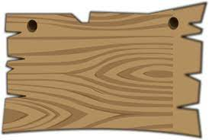
The Humber Men in Sheds Alliance has been made aware of a storage warehouse in the Hull area which is changing is use. They have a lot internal wood shelving etc which they are disposing of too good home or in our case shed!
See below the details we have: To register your sheds interest please contact Julie.cook@hwrcc.org.uk
- Sheds will need to dismantle and distribute the wood – you will need to have a conversation about with your insurance company to ensure you are covered for the task of removal. It will be a heavy task so will require fit and agile men who remove it.
- Transport – the person coordinating is likely to be able to provide delivery transport if necessary (dependent upon how many Sheds need wood immediately – they would not be able to do it after the initial delivery)
- The wood is in maybe 8ft lengths and smaller and probably 4 x 2 in size, also lots of ply in various shapes and sizes.
- Dismantling needs to take place in June 21.
- The business is doing an inventory in the next couple of weeks so we will have more details then and there may be other things available.
To register your sheds interest please contact Julie.cook@hwrcc.org.uk

