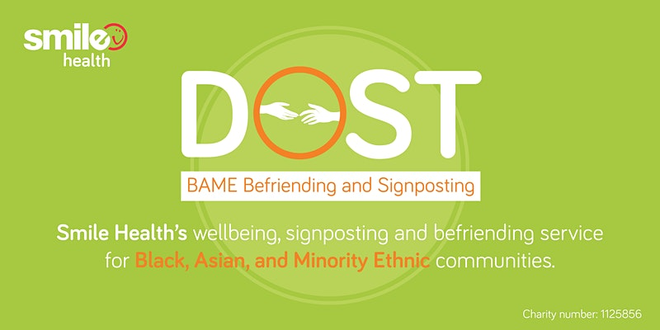

The Covid Vaccine: Busting the myths for BAME communities. Free Webinar
Active Humber is working with our partners to help in the roll out of the Covid-19 vaccination programme. We are sharing this notice that in turn you will share the information widely to support the vaccination programme.
As the NHS continues its stellar efforts of rolling out the Covid-19 vaccine, we recognise that not all of the challenges around this process are clinical. Reports over recent months have shown that significant numbers in our BAME communities have expressed a reluctance towards taking the jab.
It is for this reason, that the 'Dost' project have set up a free live Webinar/Q&A session for BAME communities in the East Yorkshire, Hull, North Lincolnshire, and North East Lincolnshire areas.
The webinar aims to increase awareness of the vaccine and challenge the myths surrounding it for our communities. You are invited to join the event and ask questions of the panel of experts.
Please find full details below. The event is free to attend.
- Date: Tuesday 2nd March
- Time: 7pm - 8:30pm
- Registration link: https://www.eventbrite.com/e/the-covid-vaccine-busting-the-myths-for-bame-communities-tickets-138325383947
- Event platform: Register via Eventbrite; Event conducted through Zoom
- Free entry
- Questions for our panel of experts can be sent in advance to dost@heysmilefoundation.org or bd@heysmilefoundation.org
The panel of experts comprises:
Dr Sharif al Ghazal - President, British Islamic Medical Association
Dr Dumbor Ngaage - Cardiothoracic surgeon, Hull University Teaching Hospitals NHS Trust
Imam Sayful Ahmed - Scunthorpe Mosque and Islamic Centre
Pandit Haridas Shukla - Hindu Chaplain, Leeds Teaching Hospital NHS Trust
Dr Shoaib Faruqi - Consultant Physician/Chest Physician at Hull University Teaching Hospitals NHS Trust
Dr Olusola Olafimihan - GP, South Holderness Practice, Withernsea
For full details and registration process, please visit: https://www.eventbrite.com/e/the-covid-vaccine-busting-the-myths-for-bame-communities-tickets-138325383947

